**26. Write a program to demonstrate random timers (Constant, Gaussian, and Poisson timers) in JMeter.**

**Constant timers:**

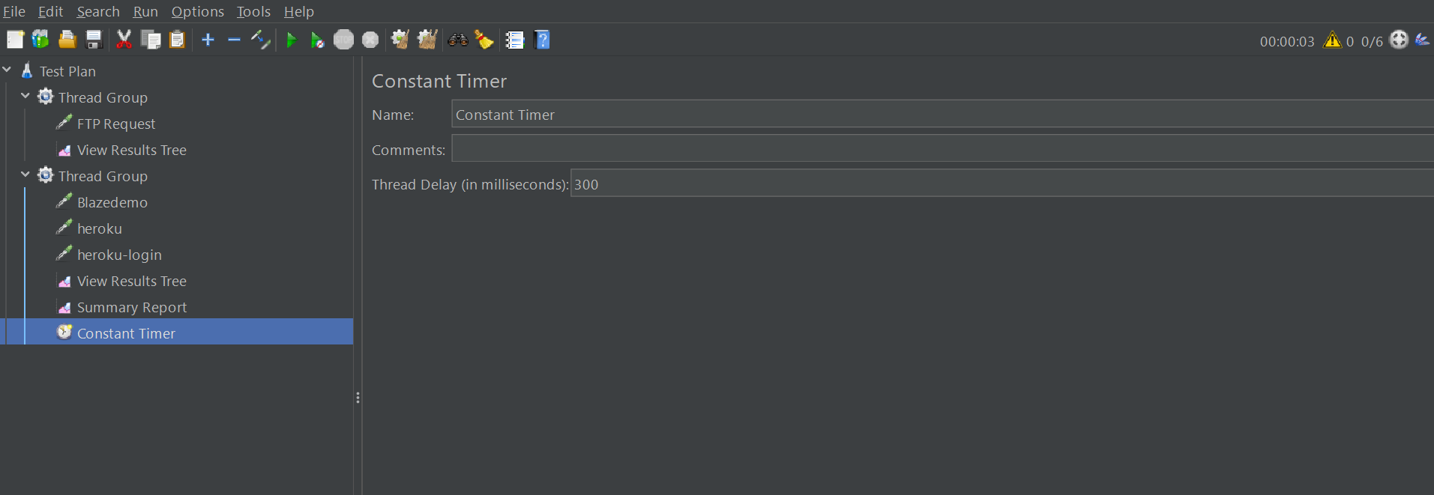

**Gaussian Random timer:**

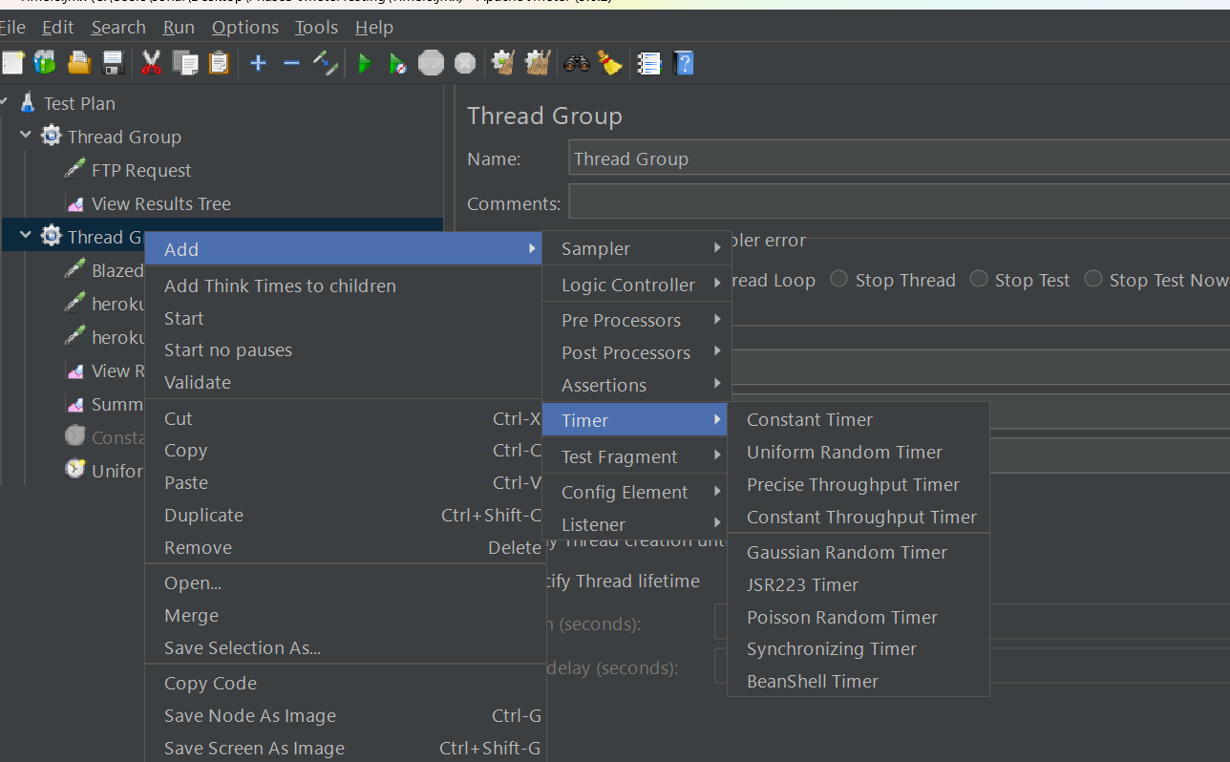

**Poisson Timer:**

